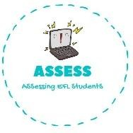
ENGLISH EXAM
Speaking

Name: Surname: N^{ber}: Grade/Class:
Assessment: | Date:
 | Teacher’s signature:  _ | Parent’s signature:

1. Look at the pictures and answer the questions.

-What is this?
-This is a ..........

-What are these? 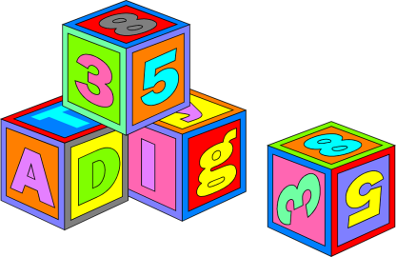
-These are ..........

-What is this?
-This is a ..........

Assessing EFL Students

