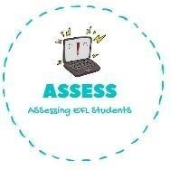
ENGLISH EXAM SPEAKING

Name: Surname: N^{ber}: Grade/Class:
Assessment: | Date:
 | Teacher’s signature:  _ | Parent’s signature:

2. Ask your partner: “Have you got ...?”
Put a tick (✓) or a cross (✕)

 | 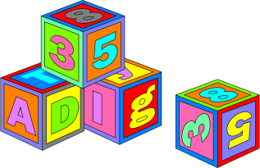 | 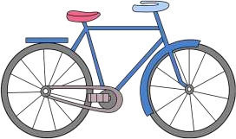

- Have you got a boke?
- Yes I have/ No, I haven’t. I have a blue bike/ I haven’t got a blue bike.
-Have you got blocks?
-Yes I have/ No, I haven’t. I have four blocks/ I haven’t got blocks.

2. Look at the pictures and answer the questions.

-What is this?
-This is a ..........

Assessing EFL Students

