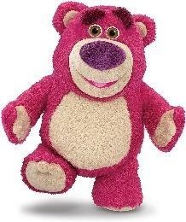
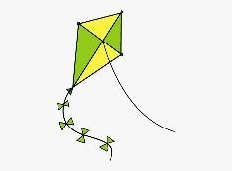
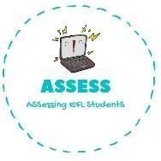
ENGLISH EXAM
Vocabulary

Name: Surname: N^{ber}: Grade/Class:
Assessment: | Date:
 | Teacher’s signature:  _ | Parent’s signature:

1. Choose the correct option.

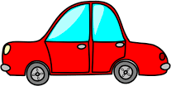
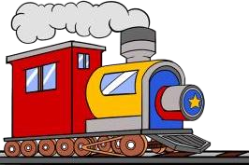

Car  Plane Chess | Train  Bike Plane | Train  Kite Ball
Computer games Car  Doll | Teddy bear  Chess Bike | Ball  Plane Kite

Assessing EFL Students

