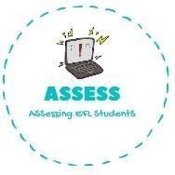
ENGLISH EXAM
Vocabulary

Name: Surname: N^{ber}: Grade/Class:
Assessment: | Date:
 | Teacher’s signature:  _ | Parent’s signature:

1. Paint with the colours given.

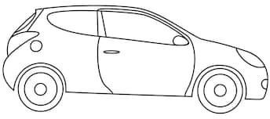
BLUE RED PINK

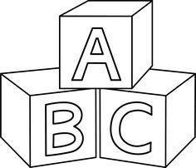
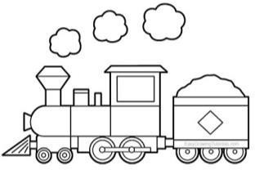
GREEN PURPLE ORANGE

YELLOW BROWN

Assessing EFL Students

