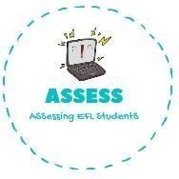
ENGLISH EXAM
Vocabulary

Name: Surname: N^{ber}: Grade/Class:
Assessment: | Date:
 | Teacher’s signature:  _ | Parent’s signature:

- Choose the correct option.

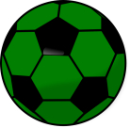
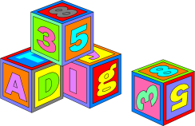
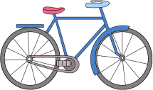

Doll  Ball  Chess | Blocks  Bike  Kite | Bike  Kite  Ball

- Order the words.
  - lbcosk
  - rac
  - lold
  - eplan
  - atrin
  - semag retupmoc
  - eikb
  - tike
  - blla
  - eddty
  - ssech

Assessing EFL Students

