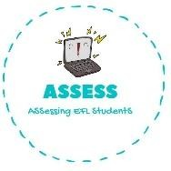
ENGLISH EXAM
Vocabulary

Name: Surname: N^{ber}: Grade/Class:
Assessment: | Date:
 | Teacher’s signature:  _ | Parent’s signature:

Match the words and the pictures.
  - Computer games
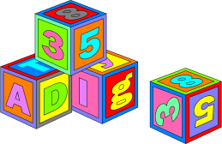 2. Car
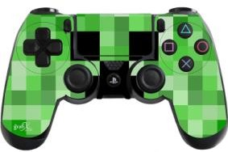 3. Plane
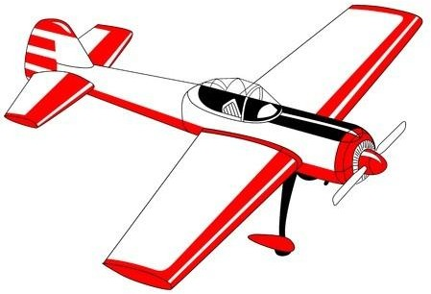
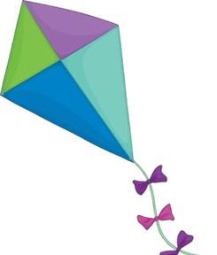 4. Blocks
5. Kite

Assessing EFL Students

