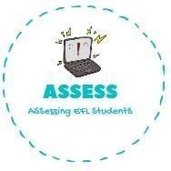
ENGLISH EXAM

Writing

Name: Surname: N^{ber}: Grade/Class:
Assessment: | Date:
 | Teacher’s signature:  _ | Parent’s signature:

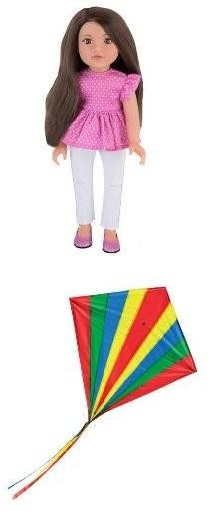
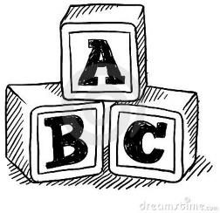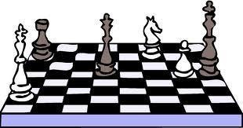1. Complete the words from the images.

D
K
T b
B
C
C g

Assessing EFL Students

