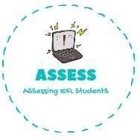
ENGLISH EXAM

Writing

Name: Surname: N^{ber}: Grade/Class:
Assessment: | Date:
 | Teacher’s signature:  _ | Parent’s signature:

What is your favourite toy? Write and draw.
My favourite toy is .

↓ You can draw here ↓

Write and paint with colours.

The doll has a skirt. || The train is . || My kite is blue and .

The bike is _ and .
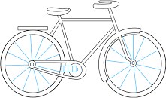
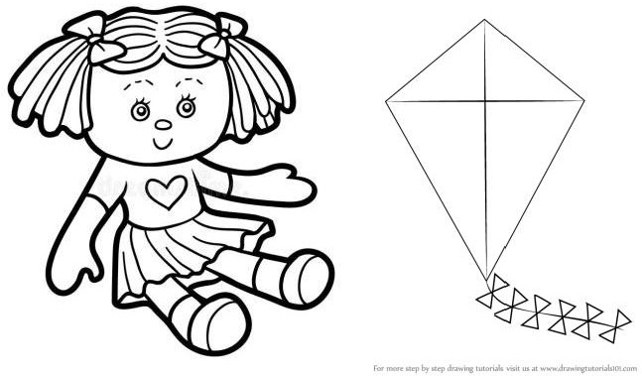
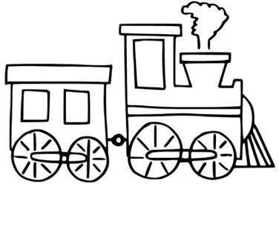

Assessing EFL Students

