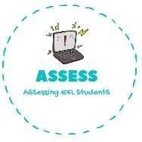
ENGLISH EXAM
Writing

Name: Surname: N^{ber}: Grade/Class:
Assessment: | Date:
 | Teacher’s signature:  _ | Parent’s signature:

- Complete the words.
  - _ite
d) Te_ _ y
c) B_ar
- Ch_ _s
- T_ai_
- C_ _
- B_ll

- Select the toys from the previous exercise.

1. 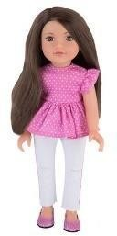 2. 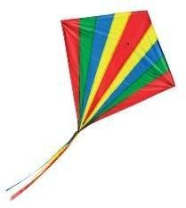 3. 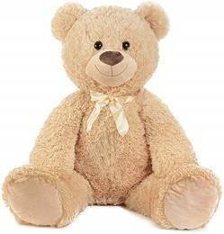 4. 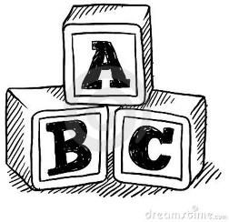
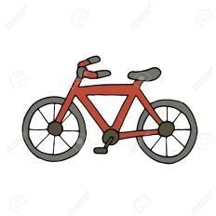
5.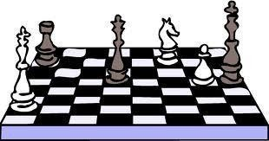 6. 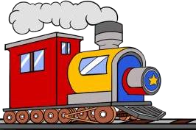 7. 8.

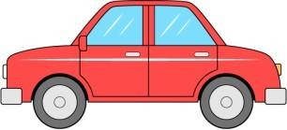
9. 10.
Assessing EFL Students

