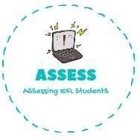
ENGLISH EXAM

Writing

Name: Surname: N^{ber}: Grade/Class:
Assessment: | Date:
 | Teacher’s signature:  _ | Parent’s signature:

- Write the correct word.
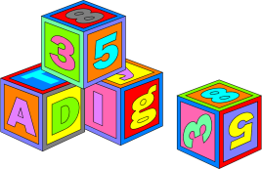
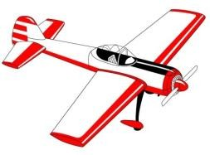

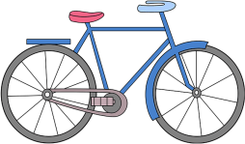

- Complete the sentences.

I have a . Have you got a ?
No, I . Yes, I .

Assessing EFL Students

