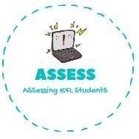
ENGLISH EXAM

Writing

Name: Surname: N^{ber}: Grade/Class:
Assessment: | Date:
 | Teacher’s signature:  _ | Parent’s signature:

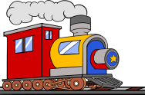
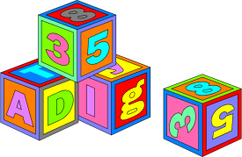
1. Order the words.

o-p-t-r-c-m-u-e a-e-g-m-s →
n-t-a-r-i →
o-d-l-l →
l-b-c-o-s-k →
s-e-s-h-c →
a-b-l-l →
e-d-t-d-y →

Assessing EFL Students

