Name: Surname: N^{ber}: Grade/Class:
Assessment: | Date:
 | Teacher’s signature: | Parent’s signature:

- Complete the sentences.

  - Have you got a ?
  - Have you got a ? 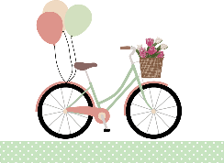
  - I haven’t got

  - I have got

  - Have you got a ?

