

# 1. Describe the toy

|  |  |  |
| --- | --- | --- |
| **Name: Surname: Nber: Grade/Class:** | | |
| **Assessment:** | **Date:** | |
| **Teacher’s signature:** | **Parent’s signature:** |

Example: 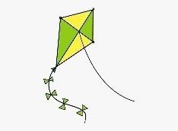The kite is green and yellow

# ENGLISH EXAM

Writing

## The is .

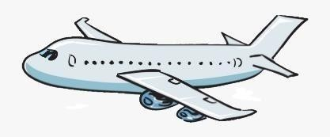 The is . 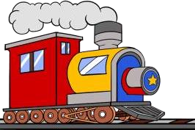 The is , and .

## The is .

Assessing EFL Students