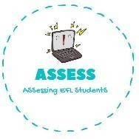
1. Answer the questions
Name: Surname: Nber: Grade/Class:
Assessment: | Date:
 | Teacher’s signature: | Parent’s signature:

ENGLISH EXAM
Writing

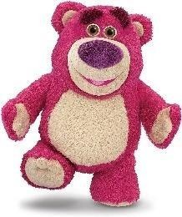

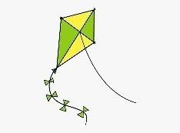

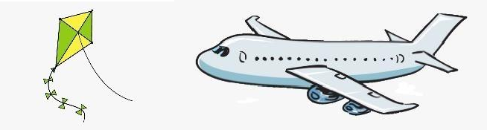

Example: How many teddy bears are there? --> There are four teddy bears

- How many trains are there? --> .
- How many planes are there? --> .
- How many teddy bears are there? --> .
- How many kites are there? --> .

Assessing EFL Students

