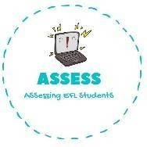
Answer the questions.
Name: Surname: Nber: Grade/Class:
Assessment: | Date:
 | Teacher’s signature: | Parent’s signature:

ENGLISH EXAM
Writing

- Have you got a teddy bear? .

- Have you got dolls? If yes, how many dolls do you have? .

- What is your favourite toy? .

- Describe your favourite toy: .

Write the name of the toys and their colour.
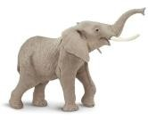
The d has a p dress.

The e is g .
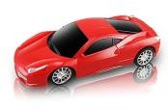
The c is all r .
The b is b and w .

Assessing EFL Students

