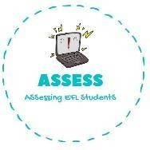
How many toys are there?
Name: Surname: N^{ber}: Grade/Class:
Assessment: | Date:
 | Teacher’s signature: | Parent’s signature:

ENGLISH EXAM

Writing

There are t_ _ k _ _ _ _.

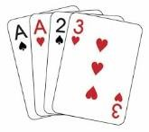
There is o _ _ r _ _ _ _ . There are f _ _ _ c _ _ _ _.

There are t _ _ _ _ t _ _ _ _ b _ _ _ _.

Complete the sentences

Linda is a  Linda has a and a Linda is wearing a dress  Has Linda a robot? | 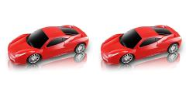  Daniel is a  He goes to school in his Daniel has two . They are r . Has Daniel a teddy bear? .

Assessing EFL Students

