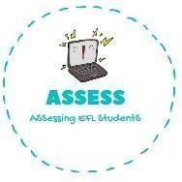
ENGLISH EXAM

Writing

Name: Surname: N^{ber}: Grade/Class:
Assessment: | Date:
 | Teacher’s signature: | Parent’s signature:

Fill the gaps with the corresponding words.

Teddy Bear | Train | Blocks | Video games
Dolls | Chess | Cars | Ball

My name is Linda and I am 9 years old, I have a lot of toys but my favourite is my his name is Pooh and I sleep with him because he is very soft. My brother sometimes leaves me his computer to play . I also like playing with his and make races together. He gave me Thomas the it is a little boring because it is not so fast, but I like it too.
I have a lot of I love dress them and brush their hair. I play with my cousins with my soccer and my making structures. My parents play and I hate it because it is very difficult for me.

Write the name of the toy and colour them.

B_ _C _ _ T_ _ _ _ B_ A_ T _ _ I _
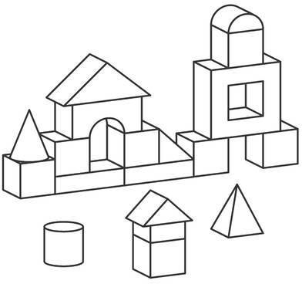
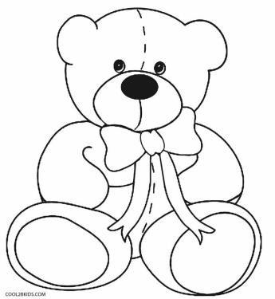
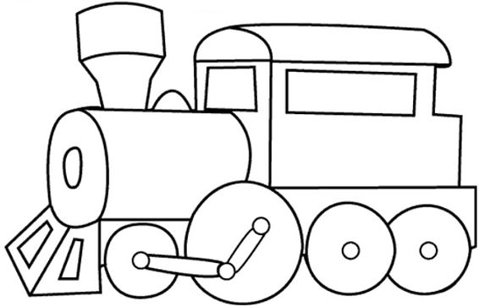

Assessing EFL Students

