

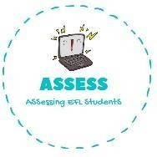1. Listen and match.



|  |  |  |
| --- | --- | --- |
| **Name: Surname: Nber: Grade/Class:** | | |
| **Assessment:** | **Date:** | |
| **Teacher’s signature:** | **Parent’s signature:** |

ENGLISH EXAM

**Listening**

|  |  |  |  |  |
| --- | --- | --- | --- | --- |
| **TOM** | **MARÍA** | **LUCY** | **MARTHA** | **JOHN** |
| **·** | **·** | **·** | **·** | **·** |

· · · · ·





Assessing EFL Students