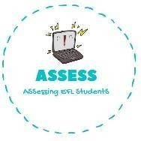
ENGLISH EXAM

Listening

Name: Surname: Nber: Grade/Class:
Assessment: | Date:
 | Teacher’s signature: | Parent’s signature:

1. Listen and complete.

My name is Lucas, I am a and I am years old. I have a lot of and what I

like the most is to
My favourite toy is my my friends love it.
with them.
_, it is big and and is very fast. My is very cool,

I also have a and when it is windy, I go to the park with my and we play with it.
Finally, I sleep everyday with my . It makes me sleep well.

Assessing EFL Students

