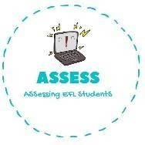
ENGLISH EXAM

Listening

Name: Surname: N^{ber}: Grade/Class:
Assessment: | Date:
 | Teacher’s signature: | Parent’s signature:

Listen and match. Then, colour them.

GREEN | YELLOW | PINK | BLACK | ORANGE

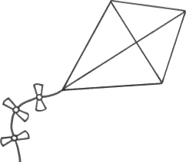
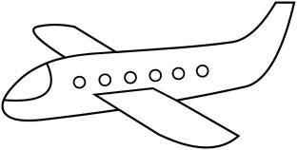
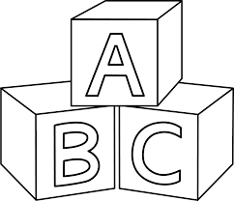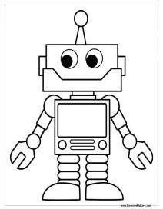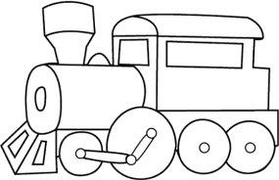

- Listen and complete the sentences

- I have blocks.
- We play with the kite when it is .
- The is new and it can .
- I like to by train
- The is the safest transport.

Assessing EFL Students

