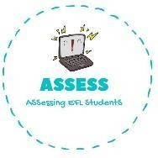
ENGLISH EXAM

Listening

Name: Surname: N^{ber}: Grade/Class:
Assessment: | Date:
 | Teacher’s signature: | Parent’s signature:
1. Listen and write TRUE or FALSE

Linda’s favourite toy is her
doll
Tom has a red robot
Jessie is a cowgirl and Tom’s favourite
toy
I always play with Tom and
Linda
My favourite toy is a
kite
I would like to have a toy
car

Assessing EFL Students

