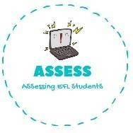
- Read and write YES or NO.
Name: Surname: N^{ber}: Grade/Class:
Assessment: | Date:
 | Teacher’s signature: | Parent’s signature:

ENGLISH EXAM

Reading

My name is John and I like to play with my toys everyday.  My favourite film is Toy Story because I love toys. My favourite toy is the doll. My doll is blonde with a skirt and a shirt. She is very funny and tells me jokes. I have a train too. It is green and black and goes very fast. I can travel to a lot of places.  My big brother has a lot of computer games and I play  with him at weekends. | - His favourite toy is the kite.  YES NO  - Her doll is blonde.  YES NO  - John has a green train.  YES NO  - He has a brother.  YES NO

- 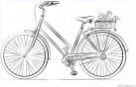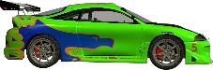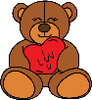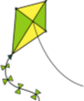Read and choose

It has four wheels, windows and goes very fast. | It can fly in the sky, but only if it is windy.
It has two ears. It is brown and very soft. | I can ride it because it has two wheels.

Assessing EFL Students

