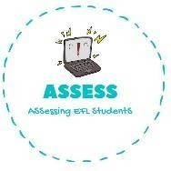
ENGLISH EXAM
Reading

Name: Surname: N^{ber}: Grade/Class:
Assessment: | Date:
 | Teacher’s signature: | Parent’s signature:

Order the words.
a. I_t_k_e → .

b. M_t_e_c_o_p_r_ua_g_s_e_m → .

c. D_y_t_e_dr_e_a_b → .

d. K_b_i_e → .

e. L_o_d_l → .

f. C_l_b_o_k → .

Select the toys from the previous exercise.

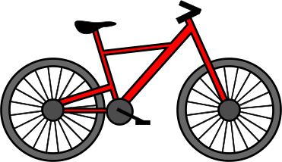
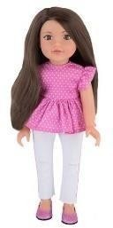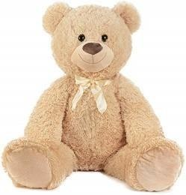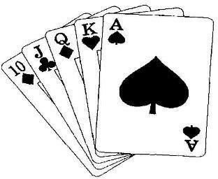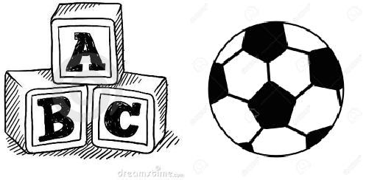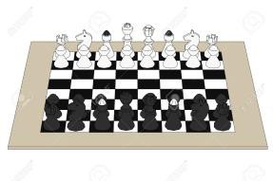

Assessing EFL Students

