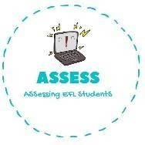
Read and select the toys Ellie likes.
Name: Surname: N^{ber}: Grade/Class:
Assessment: | Date:
 | Teacher’s signature: | Parent’s signature:

ENGLISH EXAM
Reading

Hello, my name is Ellie and I am 8 years old I have a lot of toys but my favourite is the yellow, green, blue and red kite. I like going to the park and play with it. I have a beautiful doll too with blonde hair and pink clothes. I have always wanted to have a dollhouse, but my mum says that I already have a lot of toys.
When my friends come to my house we play with cards. I also have a car that is green and blue. I play with it with my cousins. When I am sad, I like playing with my teddy bear because it is very soft and warm.
When it’s sunny my friends and I like riding with our bikes. And these are my toys.
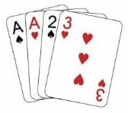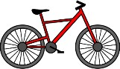

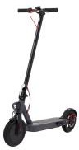
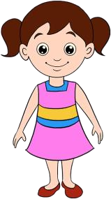
->

Name all the toys of the previous exercise and write the plural too.
Example: Doll, dolls
- E)
- F)
- G)
- H)

Assessing EFL Students

