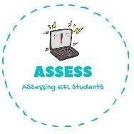
1. Answer the questions
Name: Surname: N^{ber}: Grade/Class:
Assessment: | Date:
 | Teacher’s signature: | Parent’s signature:

ENGLISH EXAM

Reading

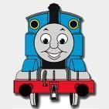
Is this a plane? YES NO

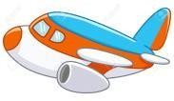 What is this? This is a .
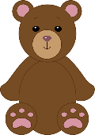

Do you have a teddy bear? YES NO

What are the kids doing? They are playing

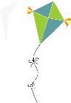

Is this a kite? YES NO

What is it? This is a .

Assessing EFL Students

