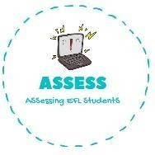
1. Choose the correct answer
Name: Surname: N^{ber}: Grade/Class:
Assessment: | Date:
 | Teacher’s signature: | Parent’s signature:

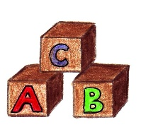
ENGLISH EXAM
Reading

- A) Cards B) Blocks C) Dolls
2. 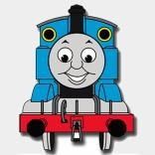 A) Train B) Car C) Plane
3. A) Ball B) Kite C) Bicycle
4. A) Teddy Bear B) Doll C) Robot

Read and complete with some words of the previous exercise.

  - I like playing with my colored , you can make structures with them.

  - This is Thomas the he is always happy and takes you anywhere.

  - My soccer is black and white and is my favourite toy.

  - I have a that is grey and strong, but I also want a that is soft and warm

Assessing EFL Students

