

# 1. Ask your partner.



|  |  |  |
| --- | --- | --- |
| **Name: Surname: Nber: Grade/Class:** | | |
| **Assessment:** | **Date:** | |
| **Teacher’s signature:** | **Parent’s signature:** |

**ENGLISH EXAM**

# Speaking

What is this? What is this? What is this?

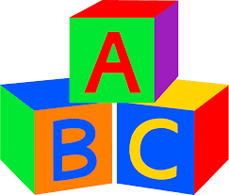

What is this? What is this? What is this?

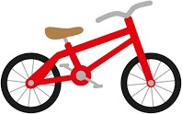

Assessing EFL Students