Name: Surname: N^{ber}: Grade/Class:
Assessment: | Date:
 | Teacher’s signature: | Parent’s signature:

Ask your partner: “Have you got...?”

Write YES or NO

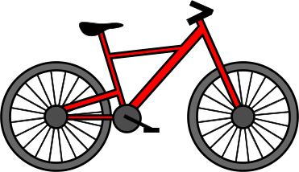 | 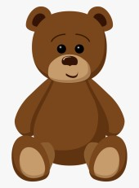 | 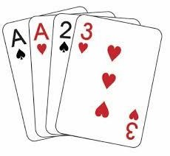 |  | 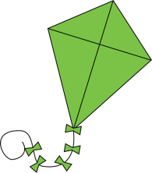

-Have you got cards?
-Yes, I have / No, I haven’t

Look at the previous pictures and ask your partner.
-Which colour is the teddy bear?

-How many cards are there?

-Do you like to play with the kite?

-Do you play football?

- What colour is the doll's dress?

