

# 1. Answer the questions.

|  |  |  |
| --- | --- | --- |
| **Name: Surname: Nber: Grade/Class:** | | |
| **Assessment:** | **Date:** | |
| **Teacher’s signature:** | **Parent’s signature:** |



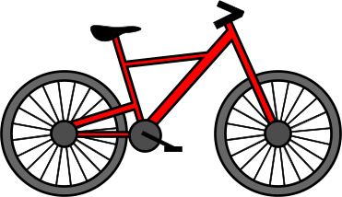

-How many teddy bears are there?

-How many dolls are there?

-Which colour is the kite?

-How many wheels does the bicycle have?

-How many blocks are there? What colour are they?

# ENGLISH EXAM

**Speaking**

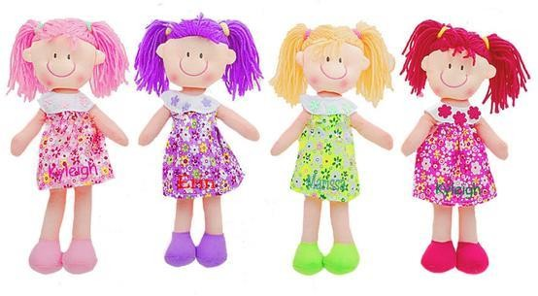

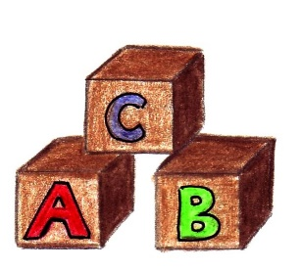

Assessing EFL Students