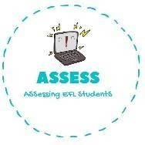
1. Answer the questions.
Name: Surname: N^{ber}: Grade/Class:
Assessment: | Date:
 | Teacher’s signature: | Parent’s signature:

-What is your favourite toy?

Draw it:

ENGLISH EXAM
Speaking

What is it? What is it? What is it?

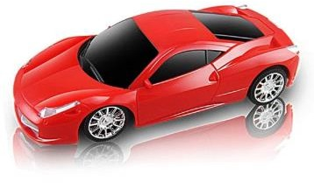

This is a p
This is a r
This is a c

-Describe the previous toys
Example: This is a ball. It is round. Its colours are black and white.

Assessing EFL Students

