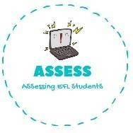
ENGLISH EXAM

Vocabulary

Name: Surname: N^{ber}: Grade/Class:
Assessment: | Date:
 | Teacher’s signature: | Parent’s signature:

- Match your favourite colour to the toy.

Red | Plane
Pink | Teddy bear
Green | Ball
Yellow | Doll
Brown | Train
Blue | Kite
Purple | Car
Black | Blocks

- Colour them following the previous exercise.

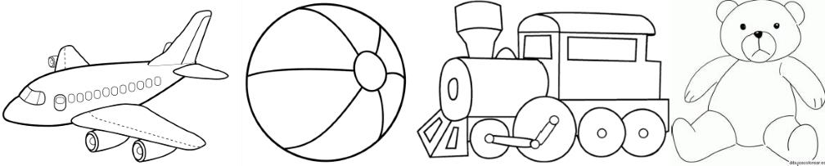
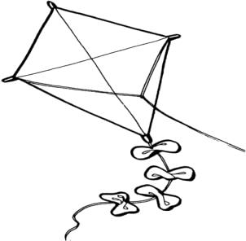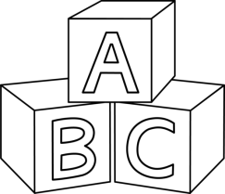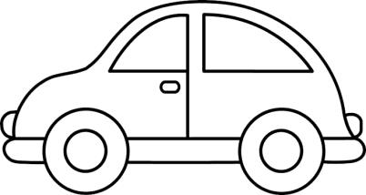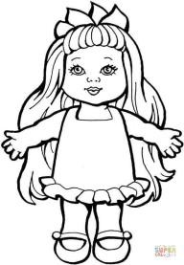

Assessing EFL Students

