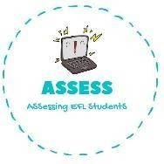
ENGLISH EXAM

Vocabulary

Name: Surname: N^{ber}: Grade/Class:
Assessment: | Date:
 | Teacher’s signature: | Parent’s signature:

1. Order the words and match them with the pictures.

- Atnhpele -->

- Ycicleb -->

- Dydet aerb -->

- Oedgavimse -->

- Obrot -->

- Nocirun -->

A) B)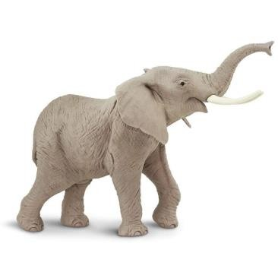 C)
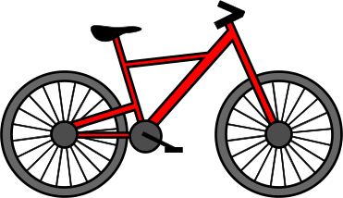
D) E) F)

Assessing EFL Students

