

1. 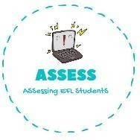**Choose the correct option**



|  |  |  |
| --- | --- | --- |
| **Name: Surname: Nber: Grade/Class:** | | |
| **Assessment:** | **Date:** | |
| **Teacher’s signature:** | **Parent’s signature:** |

ENGLISH EXAM

Vocabulary

   

|  |  |  |  |
| --- | --- | --- | --- |
| Door | Ball | Bay | Kite |
| Doll | Bell | Buy | Cat |
| Dill | Belt | Boy | Key |

1. **Match the colour with the picture and the word.**

|  |  |  |  |  |
| --- | --- | --- | --- | --- |
| **RED** | **BLUE** | **PINK** | **GREEN** | **GREY** |

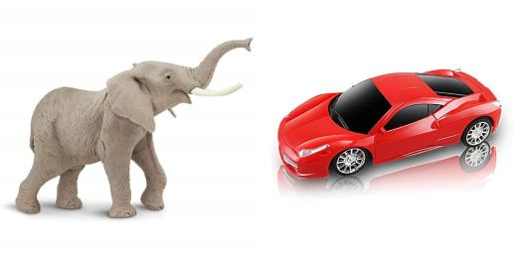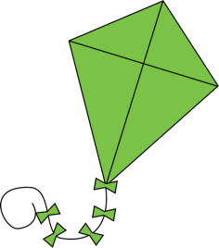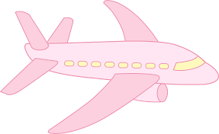

|  |  |  |  |  |
| --- | --- | --- | --- | --- |
| **PLANE** | **KITE** | **CAR** | **ELEPHANT** | **ROBOT** |

Assessing EFL Students