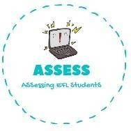
ENGLISH EXAM

Vocabulary

Name: Surname: N^{ber}: Grade/Class:
Assessment: | Date:
 | Teacher’s signature: | Parent’s signature:

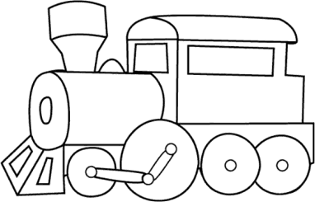
1. Paint them with the colours given and write their names.
PINK BLUE
T _ _ _ _ R _ _ _ _
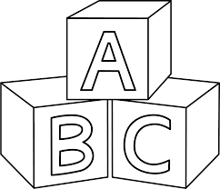
YELLOW GREEN
B _ _ _ _ _ P _ _ _ _
RED K _ _ _

Assessing EFL Students

