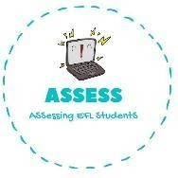
1. Find the words given in the puzzle
Name: Surname: N^{ber}: Grade/Class:
Assessment: | Date:
 | Teacher’s signature: | Parent’s signature:

ENGLISH EXAM

Vocabulary

P | L | A | N | E | M | D
A | B | G | I | R | L | O
T | E | L | F | R | I | L
K | R | Q | O | U | V | L
R | P | A | E | C | S | N
Z | C | U | I | L | K | A
C | A | R | R | N | J | S

- DOLL
- CAR
- GIRL
- PLANE
- BLOCKS
- TRAIN

Assessing EFL Students

