Name: ____________________________ Surname: ____________________________N^{ber}: ____ Grade/Class: _____
Assessment: _____________________________ | Date: ___________________________________________________
 | Teacher’s signature:  ___________________________ | Parent’s signature:  ___________________________

- Listen and circle.

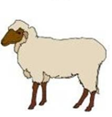

- Listen and link.

Cavin
Andrea
Mary

. . .

. . .
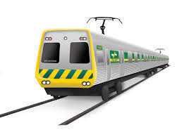
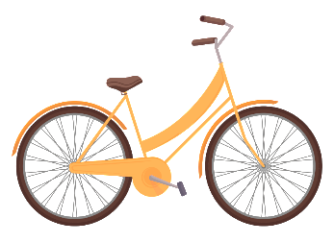
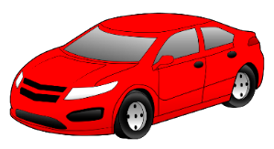

TRANSCRIPT

EXERCISE 1

- Bicycle
- Train
- Truck
- Motorbike
- Submarine
- Car

EXERCISE 2

- Mary prefers to travel by train.
- Cavin likes to travel by car.
- Andrea loves to ride a bicycle.

