Name: ____________________________ Surname: ____________________________N^{ber}: ____ Grade/Class: _____
Assessment: _____________________________ | Date: ___________________________________________________
 | Teacher’s signature:  ___________________________ | Parent’s signature:  ___________________________

- Listen and write the letters which relates to the right hand side examples.

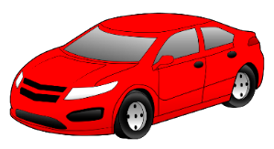
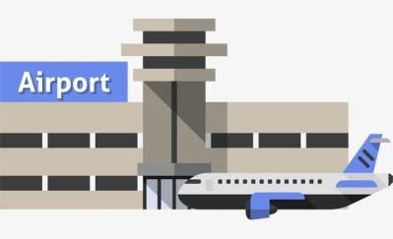

B

B
A
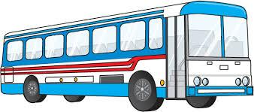
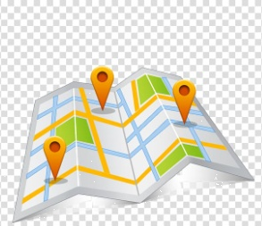
OTHER CITIES

D
C

- Listen and match.

PETER

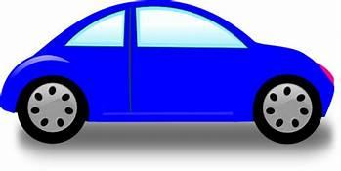
RONNIE

TRANSCRIPT

EXERCISE 1

How does Benjamin get to different Places?

Luisa: Do you have to go to lots of places for your Job, Benjamin?
Benjamin: Yes.
Benjamin: I had to go to the Airport yesterday; I drove there in my car.
Luisa: And where did you go in the morning?
Benjamin: I went to the market to buy some materials. I went by bus; it took a long time to reach there.
Luisa: How do you travel to work or your office?
Benjamin: I take my bike; it helps me reach the office on time.
Luisa: If you’ve to meet clients in other cities, how do you get there?
Benjamin: I take a train to travel to other cities. I think it is the quickest mode of transport to get there.
Luisa: Great!

EXERCISE 2

- Ronnie likes the red car.
- Peter likes the blue car.

