Name: ____________________________ Surname: ____________________________N^{ber}: ____ Grade/Class: _____
Assessment: _____________________________ | Date: ___________________________________________________
 | Teacher’s signature:  ___________________________ | Parent’s signature:  ___________________________

- Listen and colour.

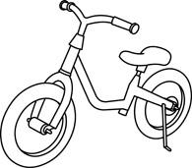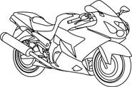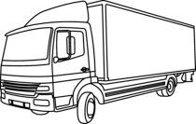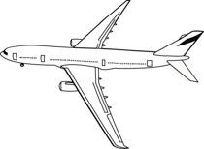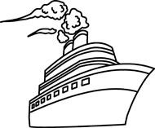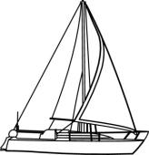

- Listen and link.
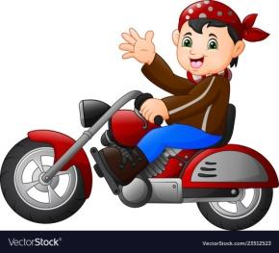
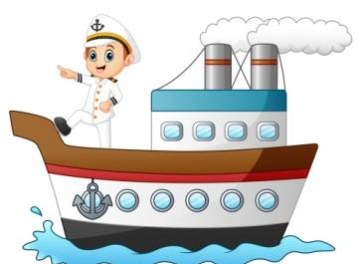

. . . .

. . . .
Daniel

David

Diana

Bruce

TRANSCRIPT

EXERCISE 1

One
Teacher: Look at the Truck. Can you find it?
Julie: Yes, I can.
Teacher: Colour the Truck blue.
Julie– OK.

Two
Teacher: Can you see the Ship?
Julie: Can I colour it?
Teacher: Yes. Colour the Ship brown!
Julie: Sure.

Three
Teacher: Find the Airplane and colour it.
Julie: What colour?
Teacher: Red.
Julie: Ok.

Four
Teacher: Now color the Sailboat.
Julie:: Yes.
Teacher: Colour the Sailboat pink.
Julie: Pink is my sister’s favourite colour!

Five
Teacher: Can you see the Bicycle?
Julie: Yes
Teacher: Now, colour the Bicycle with any of your favourite colors.
Julie: I love this!

Six
Teacher: The Motorbike is left!
Julie: Yes.
Teacher: Colour the Motorbike green.
Julie: Sure.

EXERCISE 2

- Daniel is riding a red motorbike.
- Diana is driving an orange car.
- David is the captain of the ship.
- Bruce drives a school bus.

