Name: ____________________________ Surname: ____________________________N^{ber}: ____ Grade/Class: _____
Assessment: _____________________________ | Date: ___________________________________________________
 | Teacher’s signature:  ___________________________ | Parent’s signature:  ___________________________

- Listen and number.

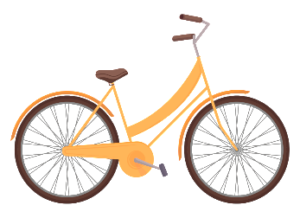
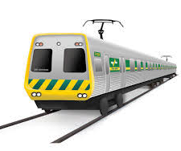
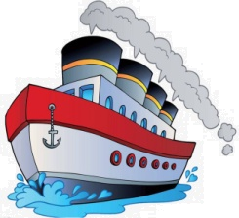

- Listen, link and colour.
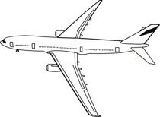
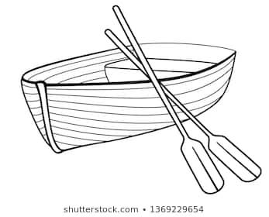

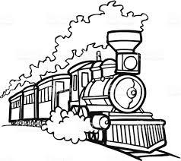
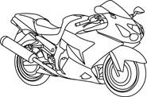

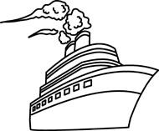
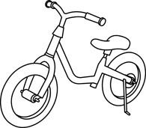

TRANSCRIPT

EXERCISE 1

- Ship
- Motorbike
- Car
- Bicycle
- Train
- Airplane
- Truck
- Sailboat

EXERCISE 2

Jenny prefers to travel in a few vehicles. Link and color all of those vehicles.

- Bus
- Train
- Airplane
- Motorbike

