Name: ____________________________ Surname: ____________________________N^{ber}: ____ Grade/Class: _____
Assessment: _____________________________ | Date: ___________________________________________________
 | Teacher’s signature:  ___________________________ | Parent’s signature:  ___________________________

- Listen and Tick.

- How does Sam travel to school?

- How does Stuart travel to school every day?
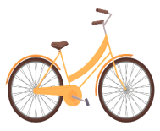

- How does George travel to school?

- How does Mary travel to college?
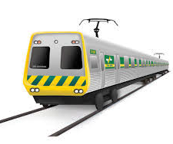

- How does Lucy travel to school every day?

- How does Mercy travel from USA to India?

- What does the teacher ask the children to draw in her art class?

TRANSCRIPT

EXERCISE 1

ONE
Sam goes to school by bus. It is a school bus.

TWO
Stuart’s father takes Stuart to school on his motorbike every day.

THREE
George goes to school on his own bicycle.

FOUR
Mary travels to her college by train.

FIVE
Lucy’s mother takes Lucy to school in her car every day.

SIX
Mercy stays with her parents in the USA. She visits her grandparents in India once a year during holidays. She travels by Airplane.

SEVEN
The teacher asked the children to draw an airplane.

