Name: ____________________________ Surname: ____________________________ N^{ber}: ____ Grade/Class: _____
Assessment: _____________________________ | Date: ___________________________________________________
 | Teacher’s signature:  ___________________________ | Parent’s signature:  ___________________________

- Read and link.
- Alice rides a bike.
- Bob drives a car.
- Martin drives a bus.
- Tony flies a plane.

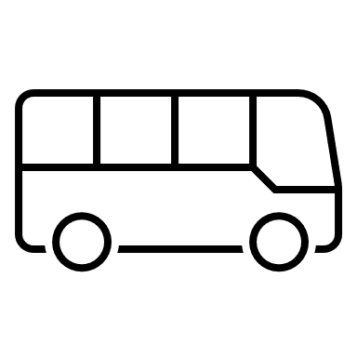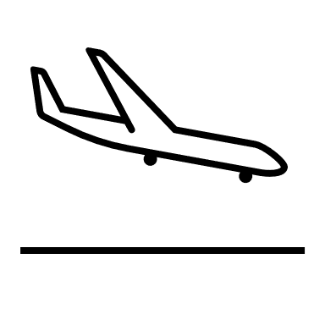
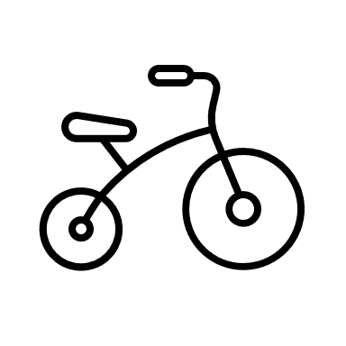
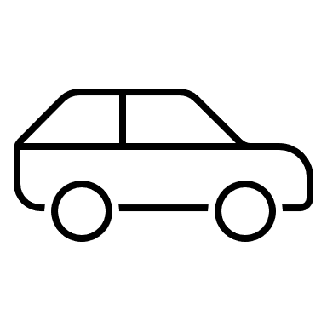

2) Read and colour the pictures in exercise 1.
a) The bus is green.
b) The car is red.
c) The bike is pink.
d) The plane is orange.

Answer key
- c; d; a; b.
- Colouring

