Name: ____________________________ Surname: ____________________________ N^{ber}: ____ Grade/Class: _____
Assessment: _____________________________ | Date: ___________________________________________________
 | Teacher’s signature:  ___________________________ | Parent’s signature:  ___________________________

Read and choose the best answer. Put a tick.

- Tim rides a bike.
a) 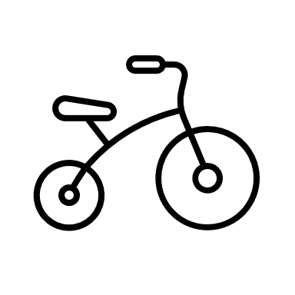 b)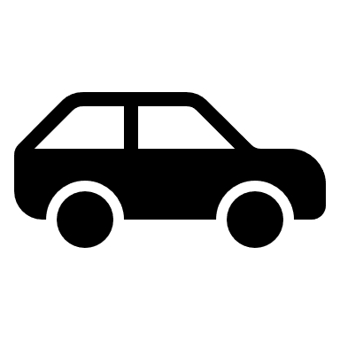 c)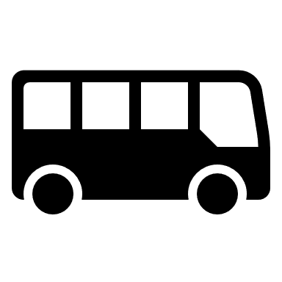

- Chido goes to work by bus.
a) b) c) 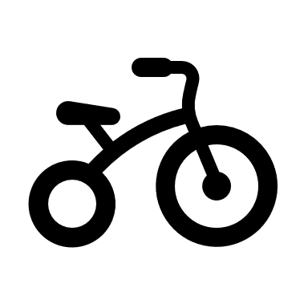

- A pilot flies a plane.
a) 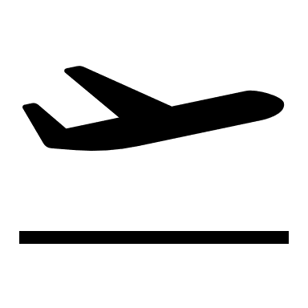 b) c)

- Faith drives a car.
a) b) c)

- There is a forest.
a) b) c)

Answer key

- a; 2. B; 3. a; 4. b; 5. a

