Name: ____________________________ Surname: ____________________________ N^{ber}: ____ Grade/Class: _____
Assessment: _____________________________ | Date: ___________________________________________________
 | Teacher’s signature:  ___________________________ | Parent’s signature:  ___________________________

- Look at the pictures.
- What is it?
- It’s a…

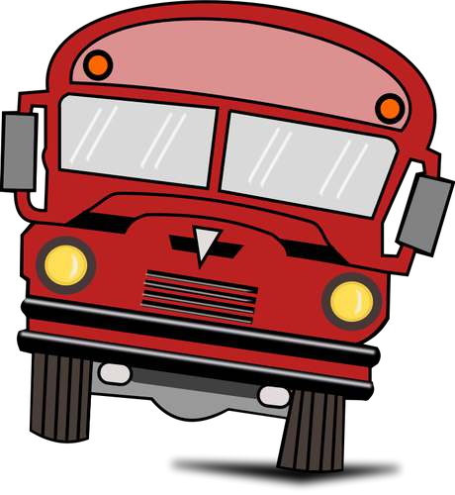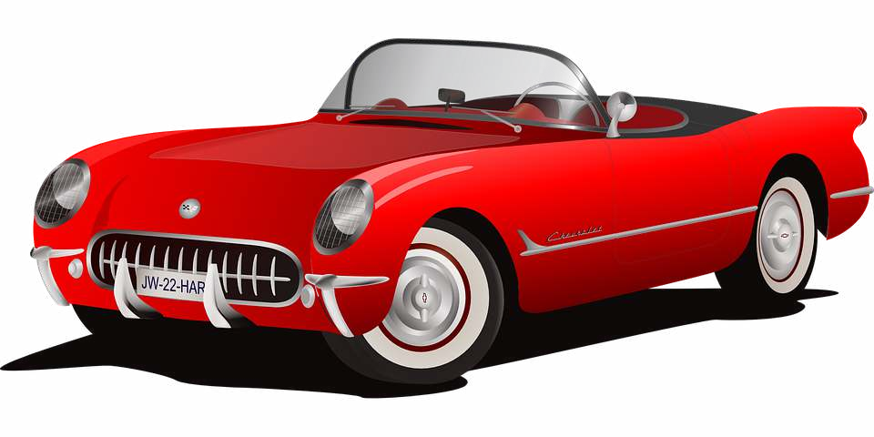

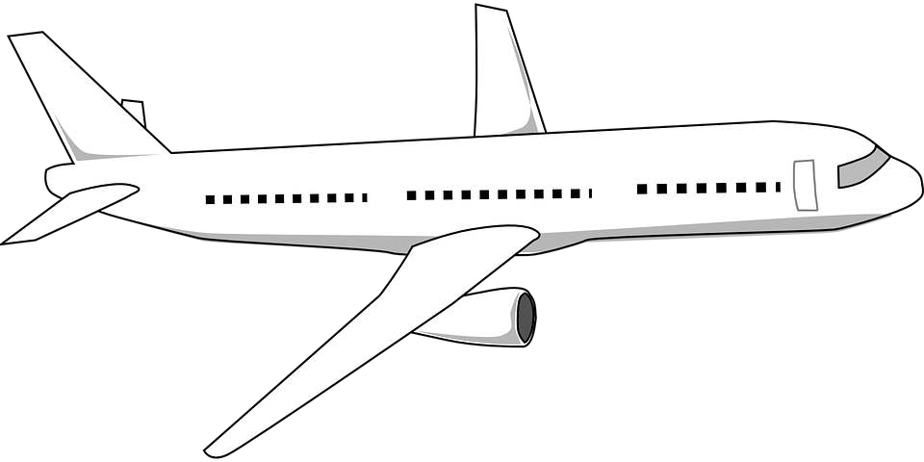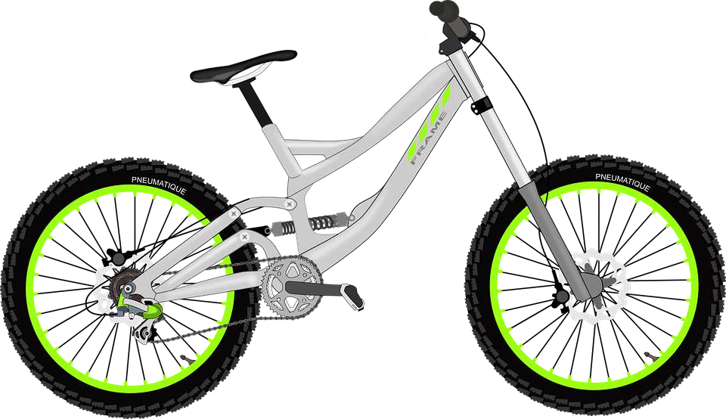

- Look at the pictures again and say:
I like……/ I don’t like…….

Answer key

- It’s a bus. It’s a car. It’s a plane. It’s a bike.

- I like bus. I don’t like train. (the answer depends on the student’s opinion)

