Name: ____________________________ Surname: ____________________________ N^{ber}: ____ Grade/Class: _____
Assessment: _____________________________ | Date: ___________________________________________________
 | Teacher’s signature:  ___________________________ | Parent’s signature:  ___________________________

Look at the pictures.

- What is it?
- It is a …

- 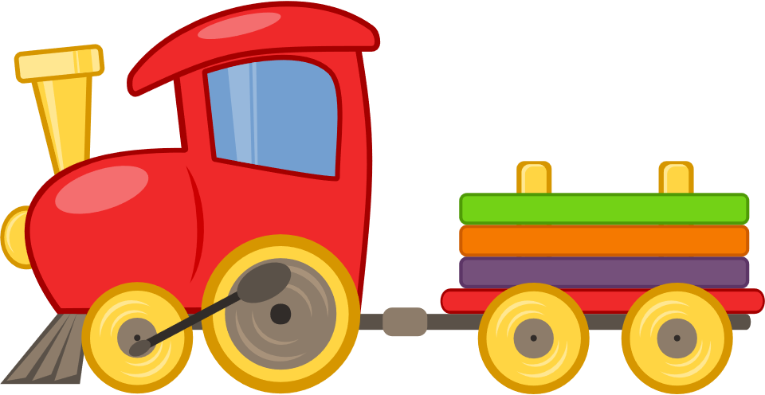 | - 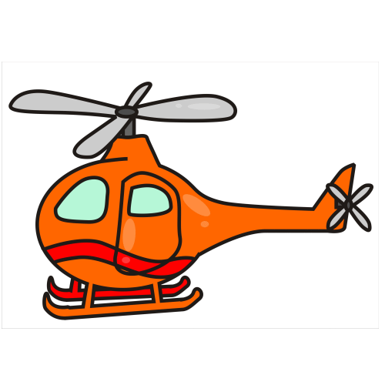
- 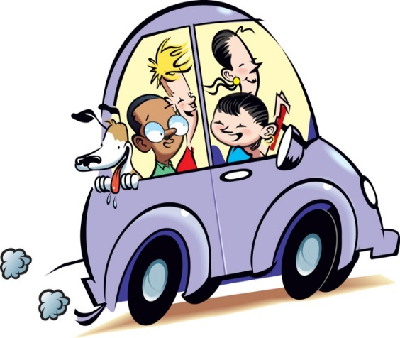 | - 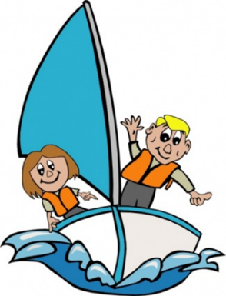

Answer key

It is a train.
It is a helicopter.
It is a car.
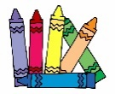
It is a boat.

