Name: ____________________________ Surname: ____________________________ N^{ber}: ____ Grade/Class: _____
Assessment: _____________________________ | Date: ___________________________________________________
 | Teacher’s signature:  ___________________________ | Parent’s signature:  ___________________________

Look at the pictures and say.

- How do you go to school?
- I go to school by….

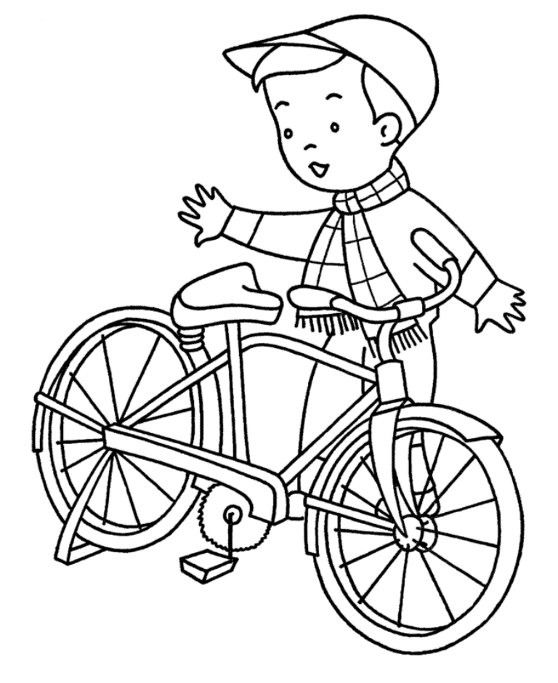
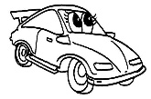

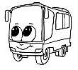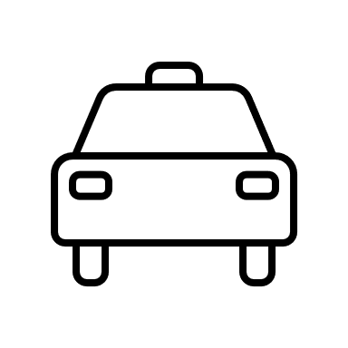

Answer key

I go to school by car.

I go to school by bike.

I go to school by bus.

I go to school by taxi.

