Name: ____________________________ Surname: ____________________________ N^{ber}: ____ Grade/Class: _____
Assessment: _____________________________  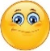 | Date: ___________________________________________________
 | Teacher’s signature:  ___________________________ | Parent’s signature:  ___________________________

Look at the pictures and say.
- Martin drives a ….
- Robert drives a …..
- Tom flies a ….
- Adam rides a ……..

Martin Robert
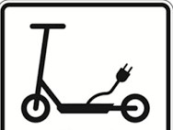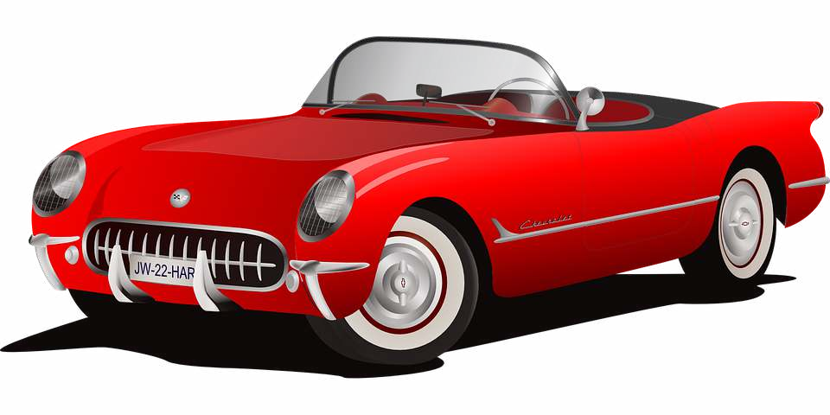

Tom Adam

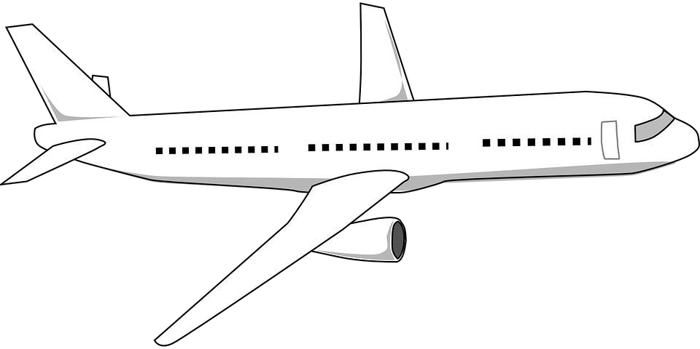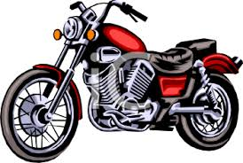

Answer key

Martin rides an e-Scooter.
Robert drives a car.
Tom flies a plane.
Adam rides a motorcycle/motorbike.

