Name: ____________________________ Surname: ____________________________ N^{ber}: ____ Grade/Class: _____
Assessment: _____________________________ | Date: ___________________________________________________
 | Teacher’s signature:  ___________________________ | Parent’s signature:  ___________________________

Look at the picture.

- Which vehicles are there?

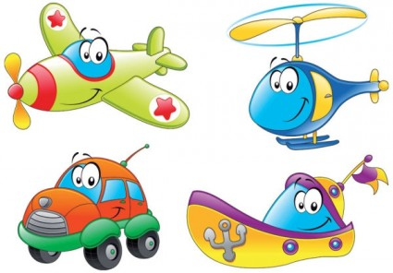

Answer key

There is a plane, a helicopter, a car and a boat.

