Name: ____________________________ Surname: ____________________________ N^{ber}: ____ Grade/Class: _____
Assessment: _____________________________  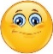  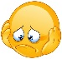  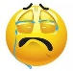 | Date: ___________________________________________________
 | Teacher’s signature:  ___________________________ | Parent’s signature:  ___________________________

1) Circle the right word. Colour.
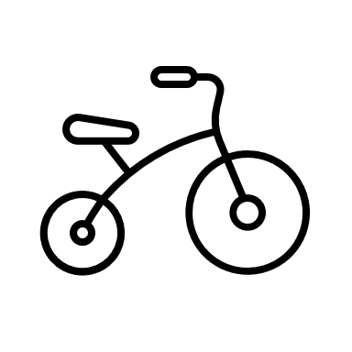
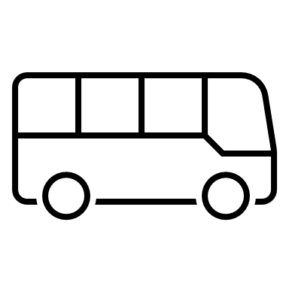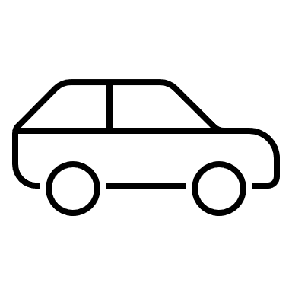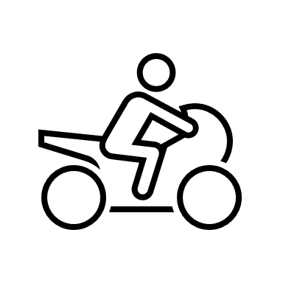
- Bus a) bicycle a) bus a) car
- Car b) car b) motorbike b) bus
- Bicycle c) bus c) car c) motorbike

2) Fill in the gaps.

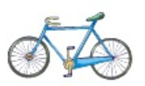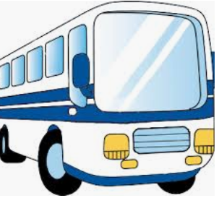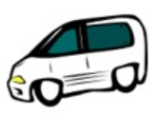
__i __y__ __ e __ u __ c __ __

Answer key

- Bus, bicycle, car, motorbike

- Bicycle, bus, car

