Name: ____________________________ Surname: ____________________________ N^{ber}: ____ Grade/Class: _____
Assessment: _____________________________  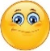  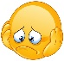  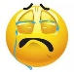 | Date: ___________________________________________________
 | Teacher’s signature:  ___________________________ | Parent’s signature:  ___________________________

- Unscramble.

- a r c ____________________________
- y c l b e i c ____________________________
- b k i e m t r o o ____________________________
- u s b ____________________________

- Label the pictures.

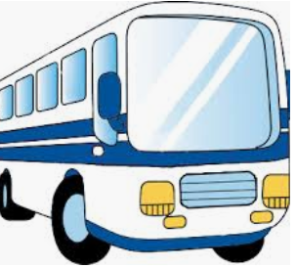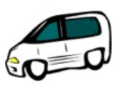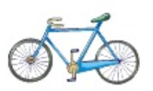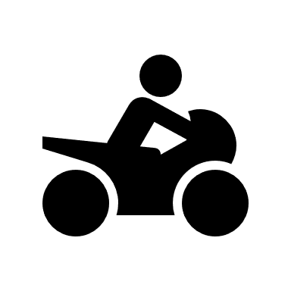
b________________ c________________ b________________ m________________

Answer key

- Car, bicycle, motorbike, bus
- Bus, car, bicycle, motorbike

