Name: ____________________________ Surname: ____________________________ N^{ber}: ____ Grade/Class: _____
Assessment: _____________________________  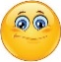  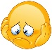  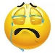 | Date: ___________________________________________________
 | Teacher’s signature:  ___________________________ | Parent’s signature:  ___________________________

- Find the words.
a m o t o r b I k e s n c a r d b I c y c l e j h b u s f r e

- Label the pictures.
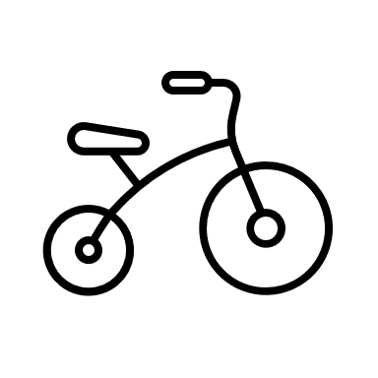
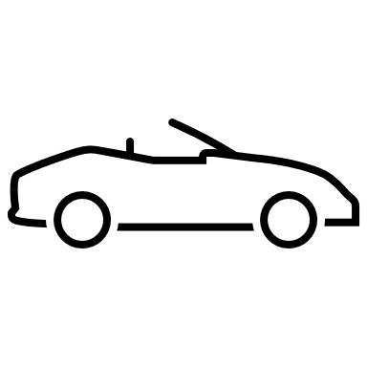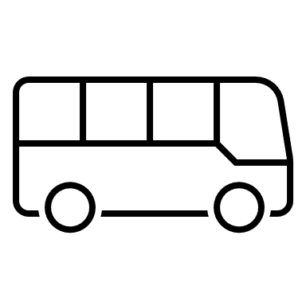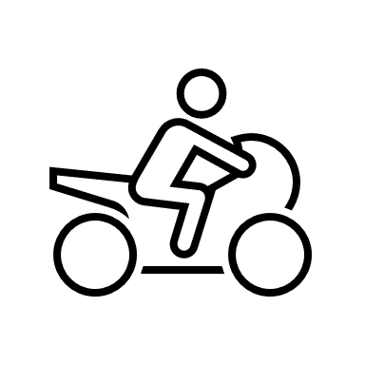

__________________ ________________ ________________ _______________

3) Colour.
a) The car is red.
b) The bicycle is green.
c) The bus is yellow.
d) The motorbike is blue.

Answer key

- m o t o r b I k e c a r b I c y c l e b u s

- Car, bus, bicycle, motorbike

- Colouring

